Class Syllabus
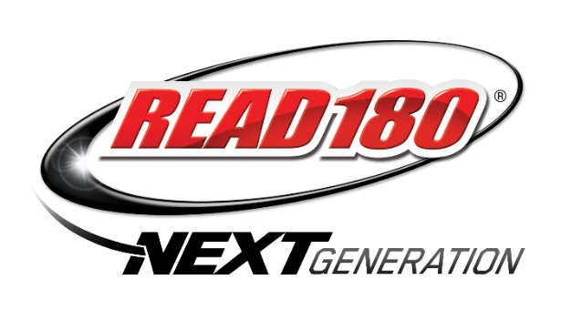
READ 180

Patty Gibson Northeast Middle School E-mail: pagibson@jmcss.org

“The more that you read, the more things you will know. The more that you learn, the more
places you'll go.”
― Dr. Seuss, I Can Read With My Eyes Shut!
Course Description:
READ 180 is an intensive reading intervention program that meets the needs of struggling readers. This program directly addresses the individual needs through differentiated instruction, adaptive and instructional software, high-interest literature, and direct instruction in reading, writing, and vocabulary skills.
Instructional methods unique to this course:
The READ 180 software includes videos mostly about science and social studies topics. Students read about the video content and engage in comprehension, vocabulary, fluency, and word-study activities around this content. In addition, audiobooks model comprehension, vocabulary, and self-monitoring strategies used by good readers, and students read leveled paperbacks in many genres. Differentiated instruction is also provided in small groups for specific skills.
Grades:
Grades will be determined by scores from activities and assessments in the READ 180 program.
S: Satisfactory N: Needs Improvement
Workbooks and Supplemental Materials:
READ 180 rBook Scholastic Read 180 Software Read 180 Library
Units of Study for the Year
Key Skills in Workshop 1: The New Americans
- Main Ideas and Details
- Synonyms and antonyms
- Identifying sentences and fragments
- Using ending punctuation
- Writing informational paragraphs

Key Skills in Workshop 2: When Disaster Strikes
- Sequencing events
- Using prefixes and suffixes
- Correcting sentence fragments
- Using capital letters
- Writing narrative paragraph
Key Skills in Workshop 3: Identify Crisis
- Story Elements
- Point of view
- Reading for details
- Identifying theme
- Figurative language
- Verb endings
- Word families
- Correcting run-on sentences
- Using correct word order
- Writing literary analysis
Key Skills in Workshop 4: Stolen Childhoods
- Summarizing
- Using a dictionary
- Multiple meaning words
- Using correct verb tense
- Using commas in a series
- Writing Informational summaries

Key Skills in Workshop 5: Under Pressure
- Problem and solution
- Homophones
- Compound words
- Using irregular verbs
- Using commas with introductory words
Key Skills in Workshop 6: Poe: The Master of Horror
- Story Elements
- Mood
- Rhyme
- Symbolism
- Text Structure
- Synonyms
- Word Families
- Subject-verb agreement
- Using possessive nouns

At Northeast Middle School, jaguars use their POWER!!
These are our school-wide rules.
P: Punctual
O: Orderly
W: Work hard
E: Engaged
R: Respectful
Consequences for students not following the POWER rules: (These accumulate from class to class and from day to day.)
- Sheet One: 1st Offense: Record behavior on “Step 1” in Behavior Binder
- Sheet One: 2nd Offence: Record behavior on “Step 2” in Behavior Binder
- Sheet One: 3rd Offence: Record behavior on “Step 3” in Behavior Binder: Parent is contacted, and student must meet with team of teachers.
- Sheet Two: 6th Offence: Parent contact, team meeting and detention is given.
- Sheet Three: 9th Offence: Required parent/teacher conference and meeting with administration. The tenth offence will receive an office referral.
**Major offences such as fighting, bullying, cursing, weapons, etc. may result in an immediate office referral.

If you have any concerns or questions, please feel free to set up a time before or after school, or you can see me during my planning time (M-F/ 10:33-11:15). You may email me at paibson@jmcss.org or call the school at 422-6687.
I am looking forward to working with your child and watching him or her grow as a proficient reader this year.

Thanks,
Patty GIbson

Please sign and return this page to let me know you received the Read 180 Syllabus and keep the rest to refer back to as the year progresses.

____________________________________________________ __________________________
Student’s Signature Date

____________________________________________________ __________________________
Parent/Guardian’s Signature Date

